**CENWP-OD-B 16 September 2022**

**MEMORANDUM FOR THE RECORD**

**SUBJECT: 22BON088 MFR AFF Valve 15 Four Chinook Mortalities**

On 16 September, Columbia River Inter-Tribal Fish Commission (CRITFC) Biologists notified Bonneville Project Biologists of four adult Chinook mortalities found on the valve 15 trash rack during raking in the Adult Fish Facility (AFF). The fish were scanned for PIT tags, inspected, and returned to the river.

**Photo 1 Mort (photo below)**

1. Species – *Oncorhynchus tshawytscha*
2. Origin – Unknown
3. Length – 63.5 cm
4. Marks and tags – No tags, Unclipped adipose fin
5. Marks and Injuries found on carcass – General decay
6. Cause and Time of Death – Unknown.
7. Future and Preventative Measures – None

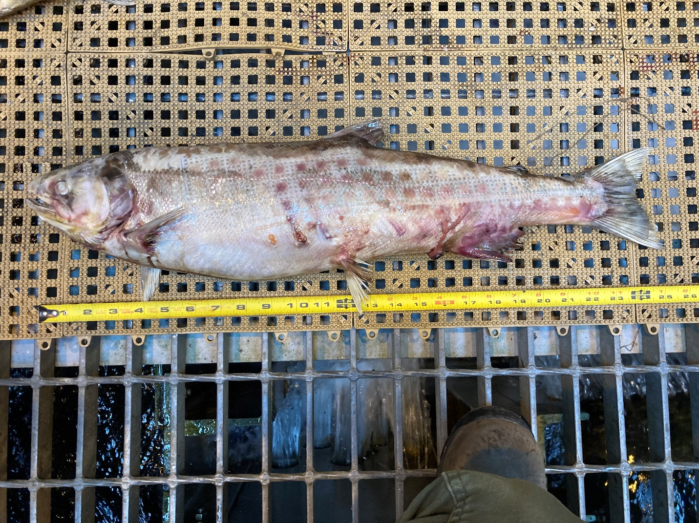

**Photo 1**

**Photo 2 Mort (Photo below)**

1. Species – *Oncorhynchus tshawytscha*
2. Origin – Unknown
3. Length – 52 cm
4. Marks and tags – No tags, Clipped adipose fin
5. Marks and Injuries found on carcass – General decay
6. Cause and Time of Death – Unknown.
7. Future and Preventative Measures – None

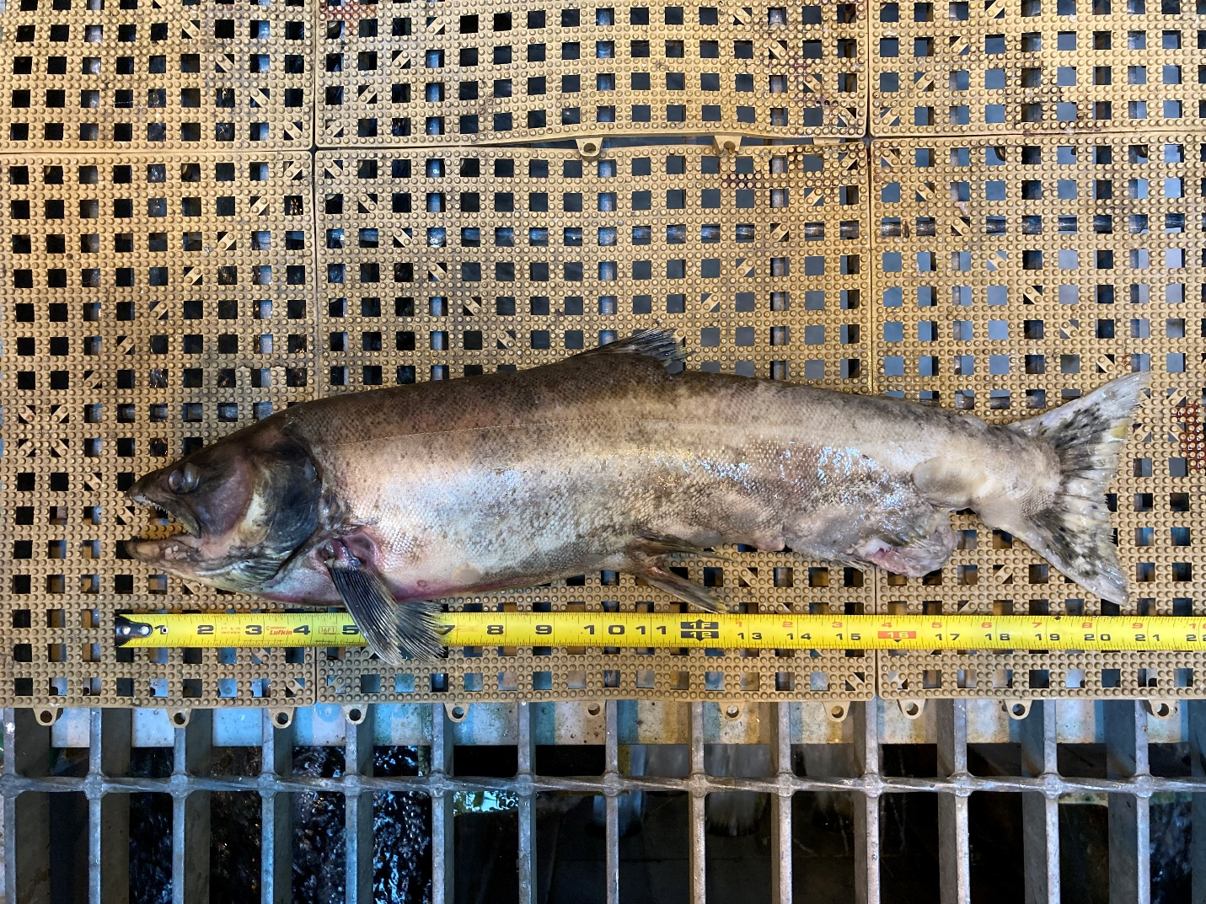

**Photo 2**

**Photo 3 Mortalities (photo below)**

1. Species – *Oncorhynchus tshawytscha*
2. Origin – Unknown
3. Length – Top: 60 cm, bottom: 69 cm
4. Marks and tags – Both fish in photo below had no tags and clipped adipose fins
5. Marks and Injuries found on carcass – General decay
6. Cause and Time of Death – Unknown.
7. Future and Preventative Measures – None

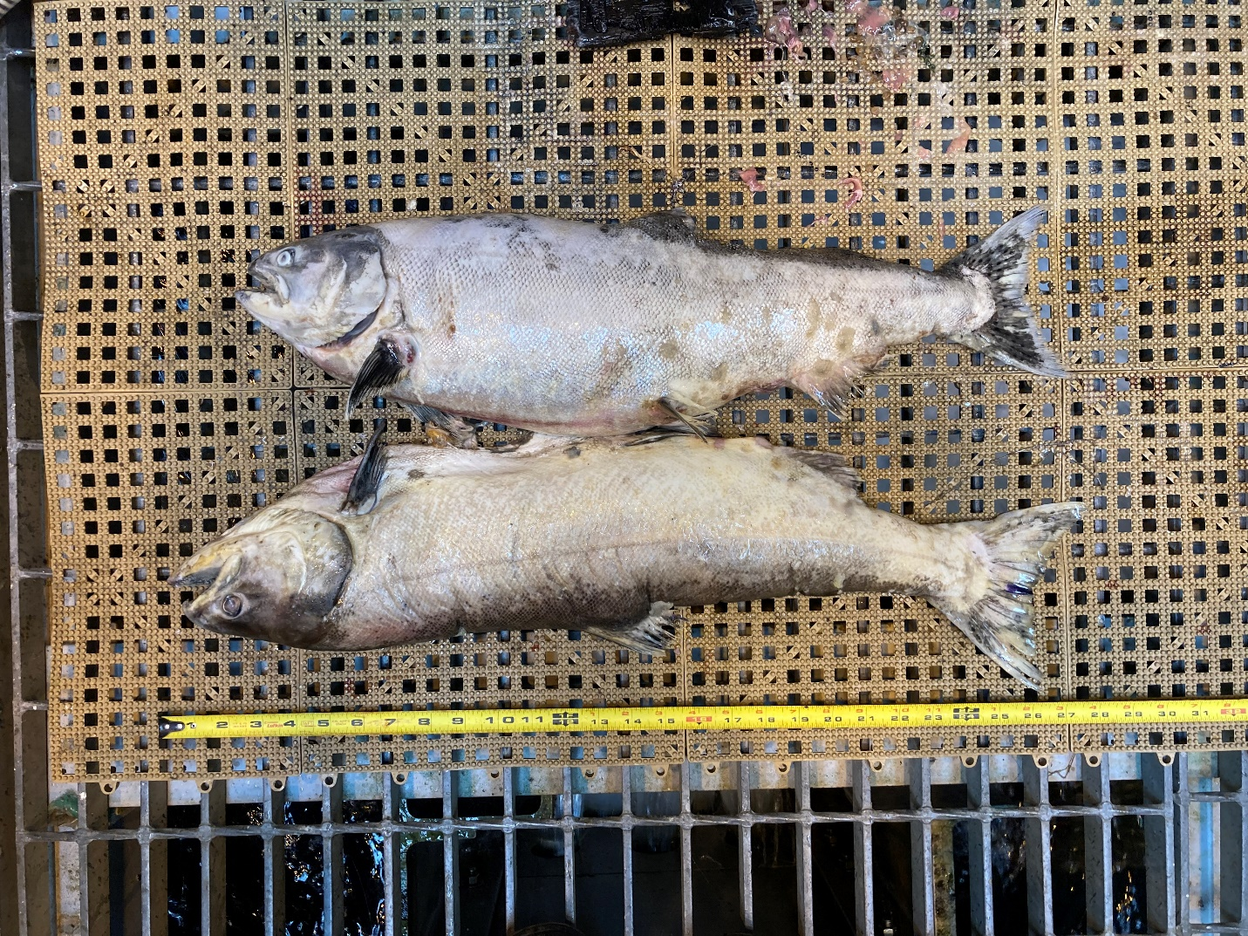

**Photo 3 Mortalities**

Sincerely,

Bonneville Project Fisheries